Software Installation (One-time)
- Install Claude Desktop: Download here.
- Install Python (3.11) if not already installed.
https://www.python.org/ftp/python/3.11.9/python-3.11.9-amd64.exe
  - Check with:
  - python --version
- (Optional) Install VS Code Python extension.

🔹 Project Setup in VS Code
- Open VS Code → create a new folder (e.g., MCP) → open it in VS Code.
- Create a virtual environment in terminal:
  - python -m venv .venv
- Activate the virtual environment:
  - Windows (PowerShell):
.venv\Scripts\Activate
  - macOS/Linux:
source .venv/bin/activate
✅ Now you should see (.venv) prefix in your terminal.
- Install required packages (inside venv):
pip install mcp[cli]
pip install --upgrade typer
pip install uv

🔹create main.py
🔹 Write Your Server Code

🔹 Install & Run the MCP Server
Still inside the .venv environment:
uv run mcp install main.py

Setup Claud Desktop

This will create a new MCP server project structure.
- Open Claud Desktop , enable develop mode ( for first timer user)
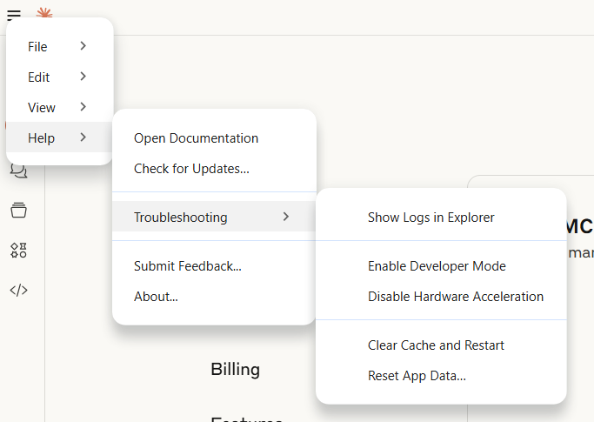
- Go To File -> Settings -> Developer -> Edit Config [ check the path to main.py ]
- In Developer option Click on Leave manager -> this should be in mode Running

Test the Query on server
Go to main Claud Desktop and find this icon 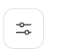 so that your Leave Manager can be running and can be used
Type the Query - How many leaves are available for employee E001
Give permission – Allow always

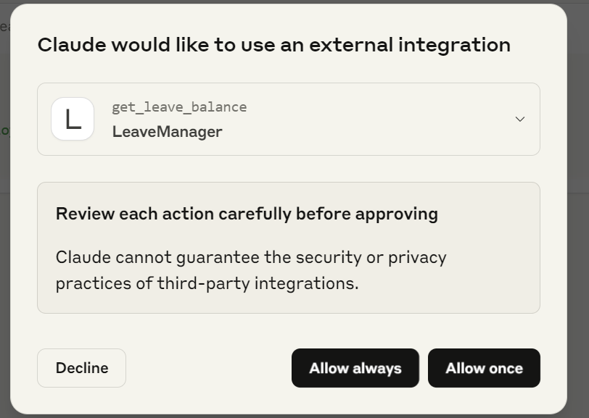

Config file :
{
"mcpServers": {
"WeatherBreakfastSuggester": {
"command": "C:\\Python\\Scripts\\uv.EXE",
"args": [
"run",
"--with",
"mcp[cli]",
"mcp",
"run",
"C:\\Users\\AbhishekShrivastav\\Desktop\\mcp\\my_first_mcp_server\\main.py"
]
}
}
}

